EXPT NO: 3 | IMPLEMENTATION OF CONVOLUTIONAL NEURAL NETWORKS (CNNs) FOR IMAGE CLASSIFICATION
DATE: 28-08-2026

PRE-LAB QUESTIONS (PROVIDE BRIEF ANSWERS TO THE FOLLOWING QUESTIONS)
- What is a Convolutional Neural Network (CNN)?
A Convolutional Neural Network (CNN) is a deep learning model mainly used for image processing and recognition. It automatically learns features such as edges, shapes, and objects from images.
- What are the functions of convolution and pooling layers in a CNN?

  - Convolution layer: Extracts important features such as edges, textures, and patterns from an image using filters.
  - Pooling layer: Reduces the spatial size of feature maps, decreasing computation and helping prevent overfitting.

- Differentiate between image classification and object detection.

  - Image Classification: Identifies the class or category of an entire image.
  - Object Detection: Identifies objects in an image and also determines their location using bounding boxes.

- Why is image preprocessing important before training a CNN model?

Image preprocessing makes images suitable for training by performing operations such as resizing, normalization, and data augmentation. It improves training speed, stability, and model performance.

- What are the advantages of using benchmark datasets such as CIFAR-10 or Kaggle image datasets.

Benchmark datasets provide standardized and realistic data for testing models. They make it easier to compare different CNN architectures and evaluate model performance using established datasets.

AIM
To design, implement, and evaluate a Convolutional Neural Network (CNN) for image classification using a benchmark image dataset.

SOFTWARE REQUIREMENTS
- Python
- TensorFlow/Keras or PyTorch
- Google Colab
- Matplotlib
- Kaggle Dataset (e.g., CIFAR-10, Cats vs Dogs, Intel Image Classification)

OBJECTIVES
Students will be able to:
- Understand the architecture of Convolutional Neural Networks.
- Implement a CNN model for image classification.
- Train and evaluate a CNN using a real-world image dataset.
- Visualize training and validation performance.
- Analyze the effectiveness of CNNs for image recognition tasks.

Task A: DATASET PREPARATION
- Perform the following tasks:
- Download an image dataset from Kaggle or use CIFAR-10.
- Load the dataset.
- Preprocess images by resizing and normalization.
- Split the dataset into training, validation, and testing sets.

Task B: CNN MODEL IMPLEMENTATION
Build a CNN model consisting of:
- Convolution layers
- ReLU activation
- Max Pooling layers
- Fully Connected layers
- Softmax output layer

Compile the model using:
- Appropriate optimizer
- Cross-entropy loss function

Task C: MODEL TRAINING AND EVALUATION
Train the CNN model.
Record:
- Training accuracy
- Validation accuracy
- Training loss
- Validation loss
- Testing accuracy
Plot:
- Accuracy vs Epoch
- Loss vs Epoch

Task D: PERFORMANCE ANALYSIS
Analyze:
- Classification accuracy
- Confusion Matrix
- Sample predictions
- Misclassified images
Discuss the strengths and limitations of CNNs for image classification.

CODE: CONATAINS STUDENT ROLL NOS
SCREENSHOT OF CODE & OUTPUT:

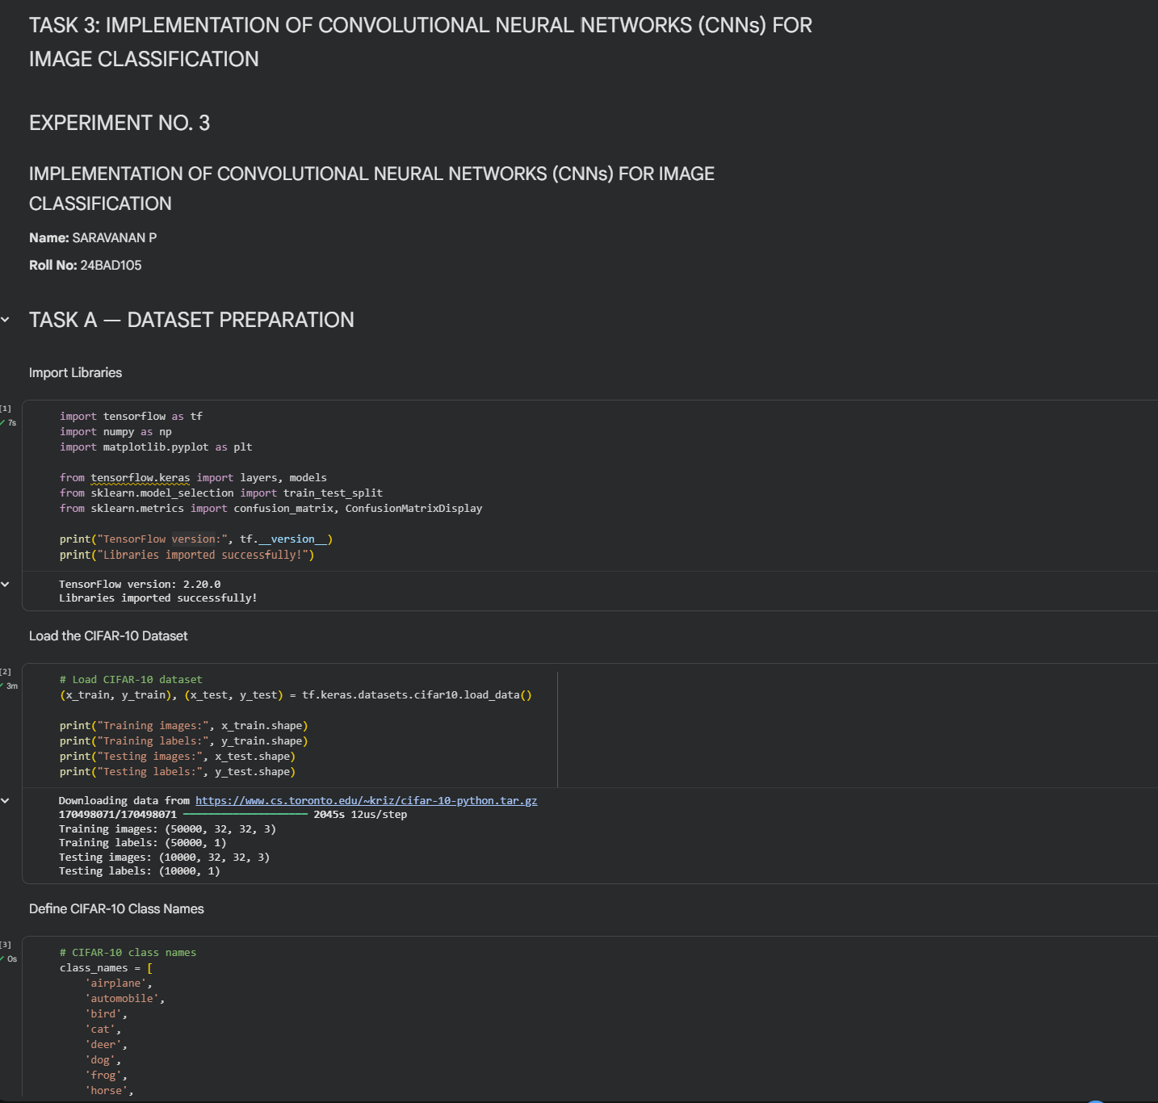

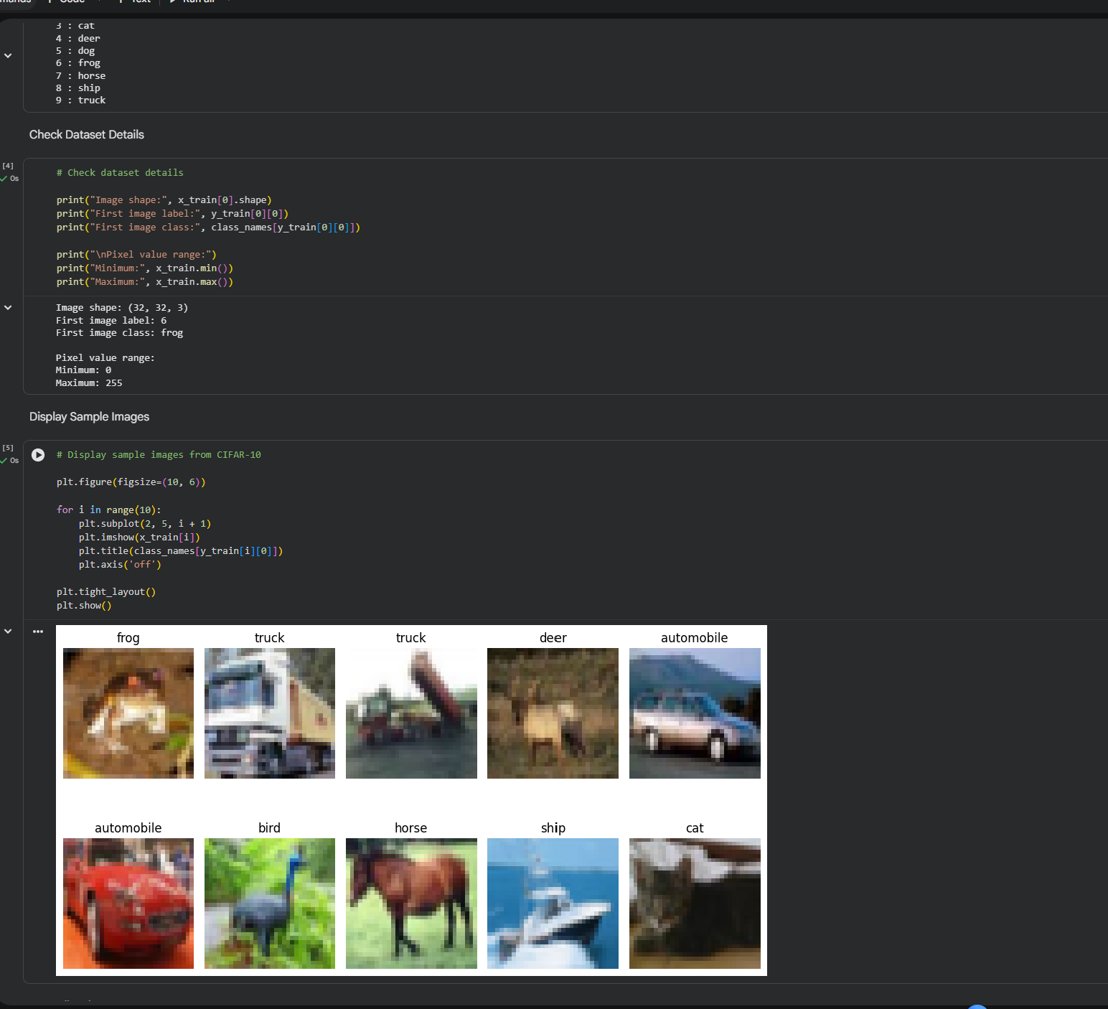

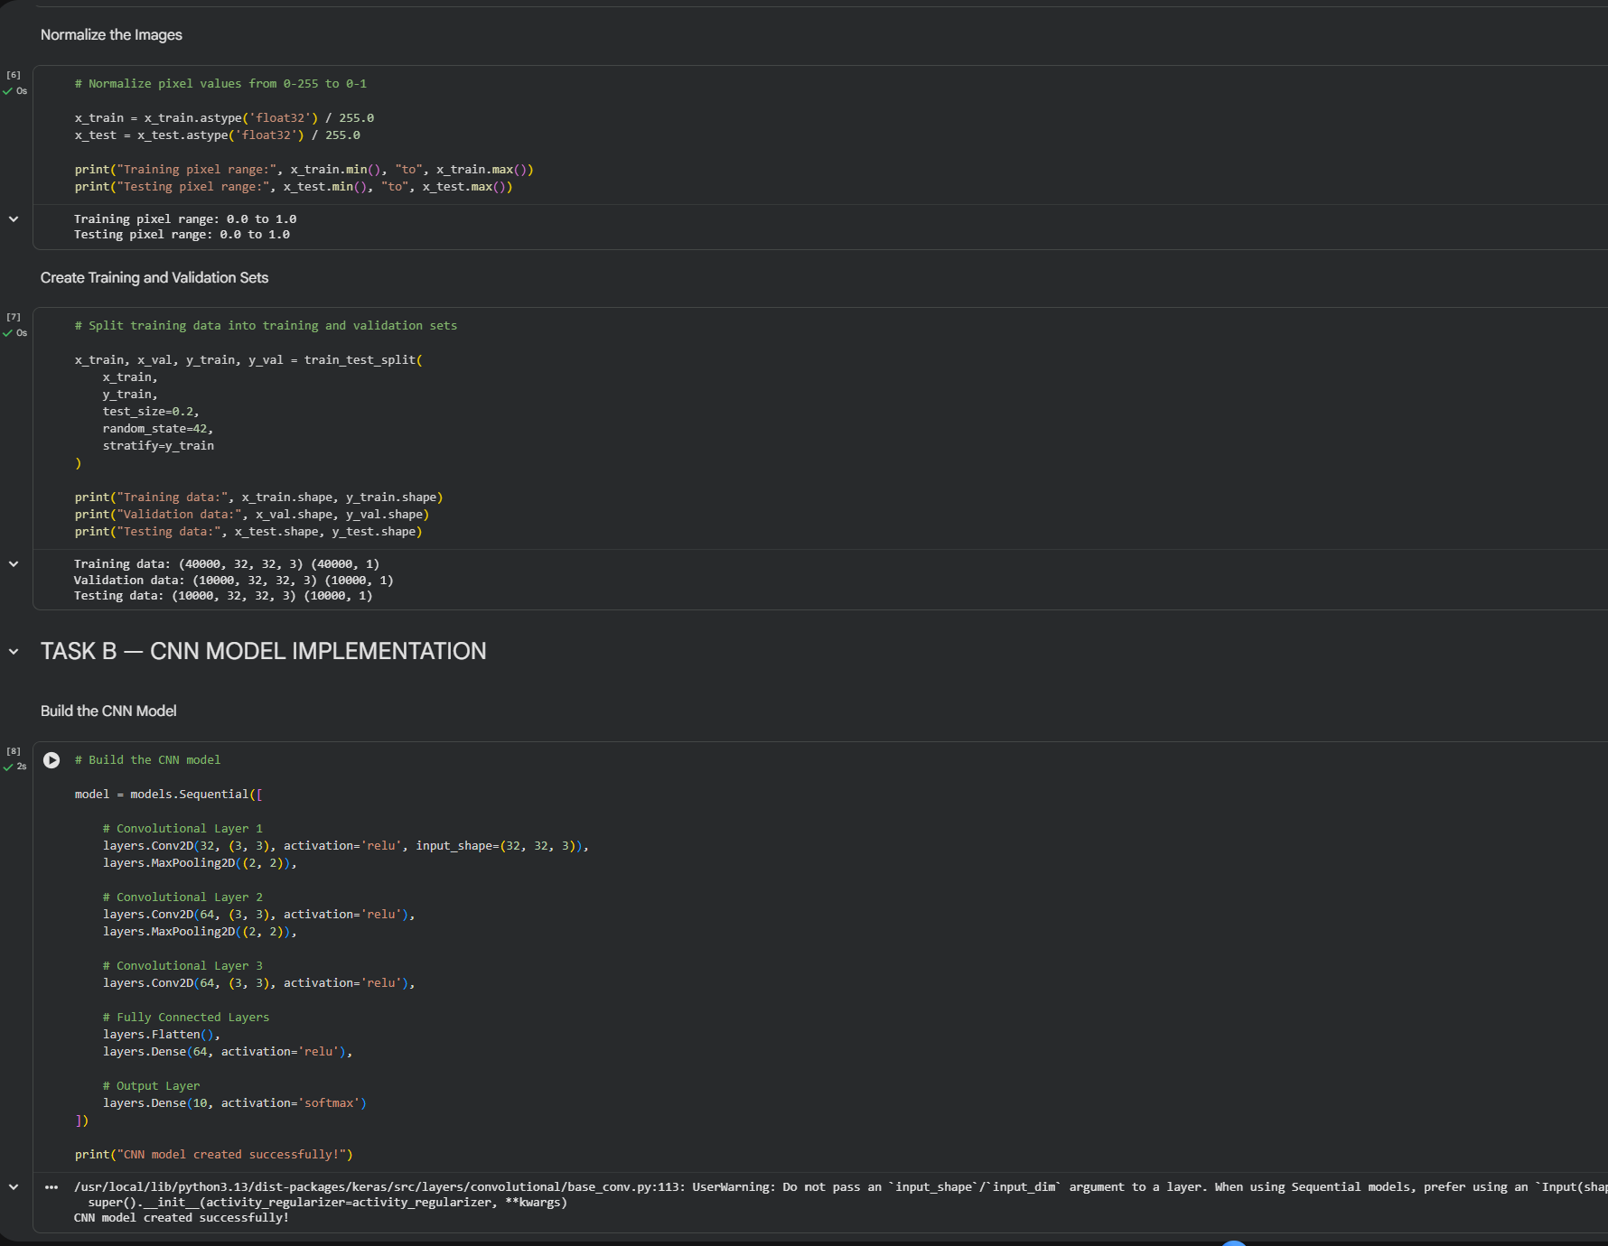

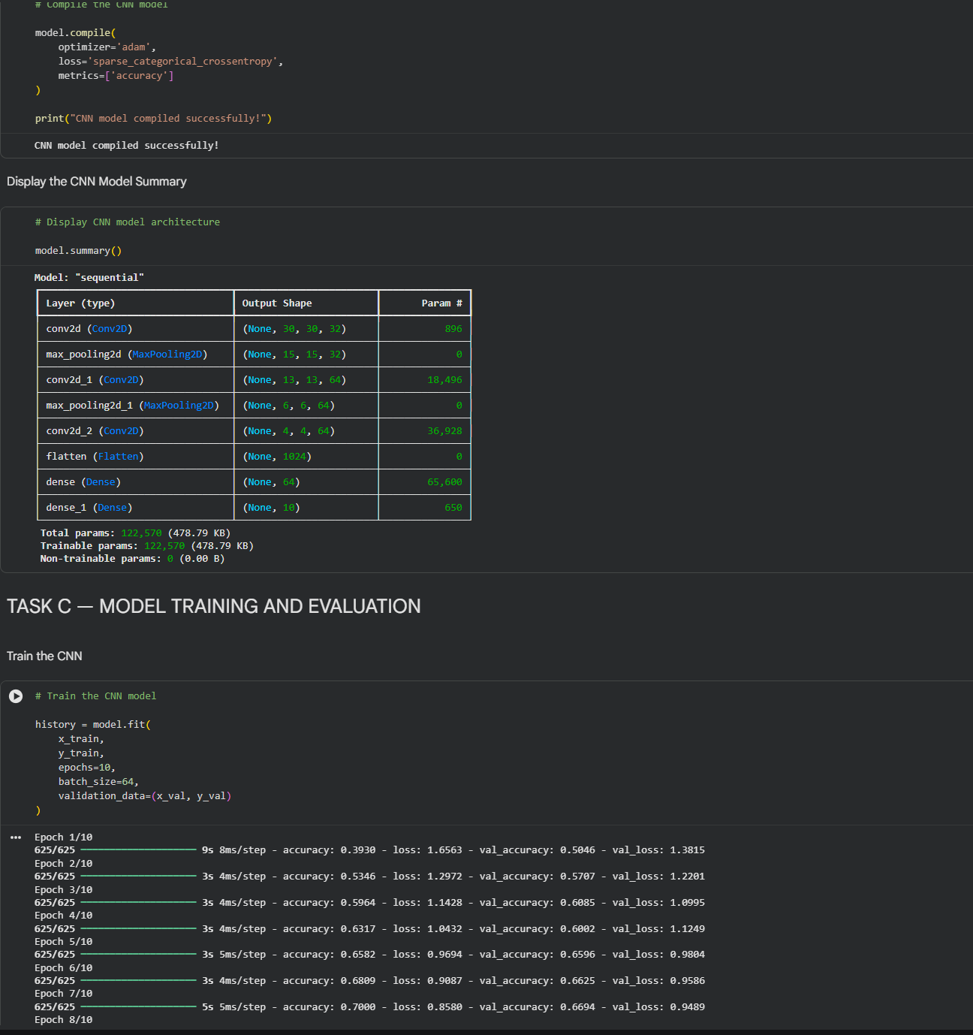

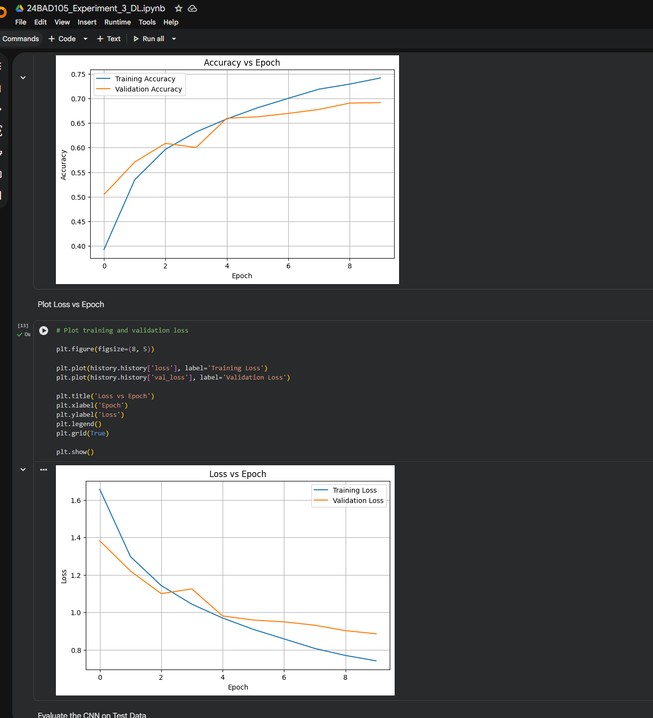

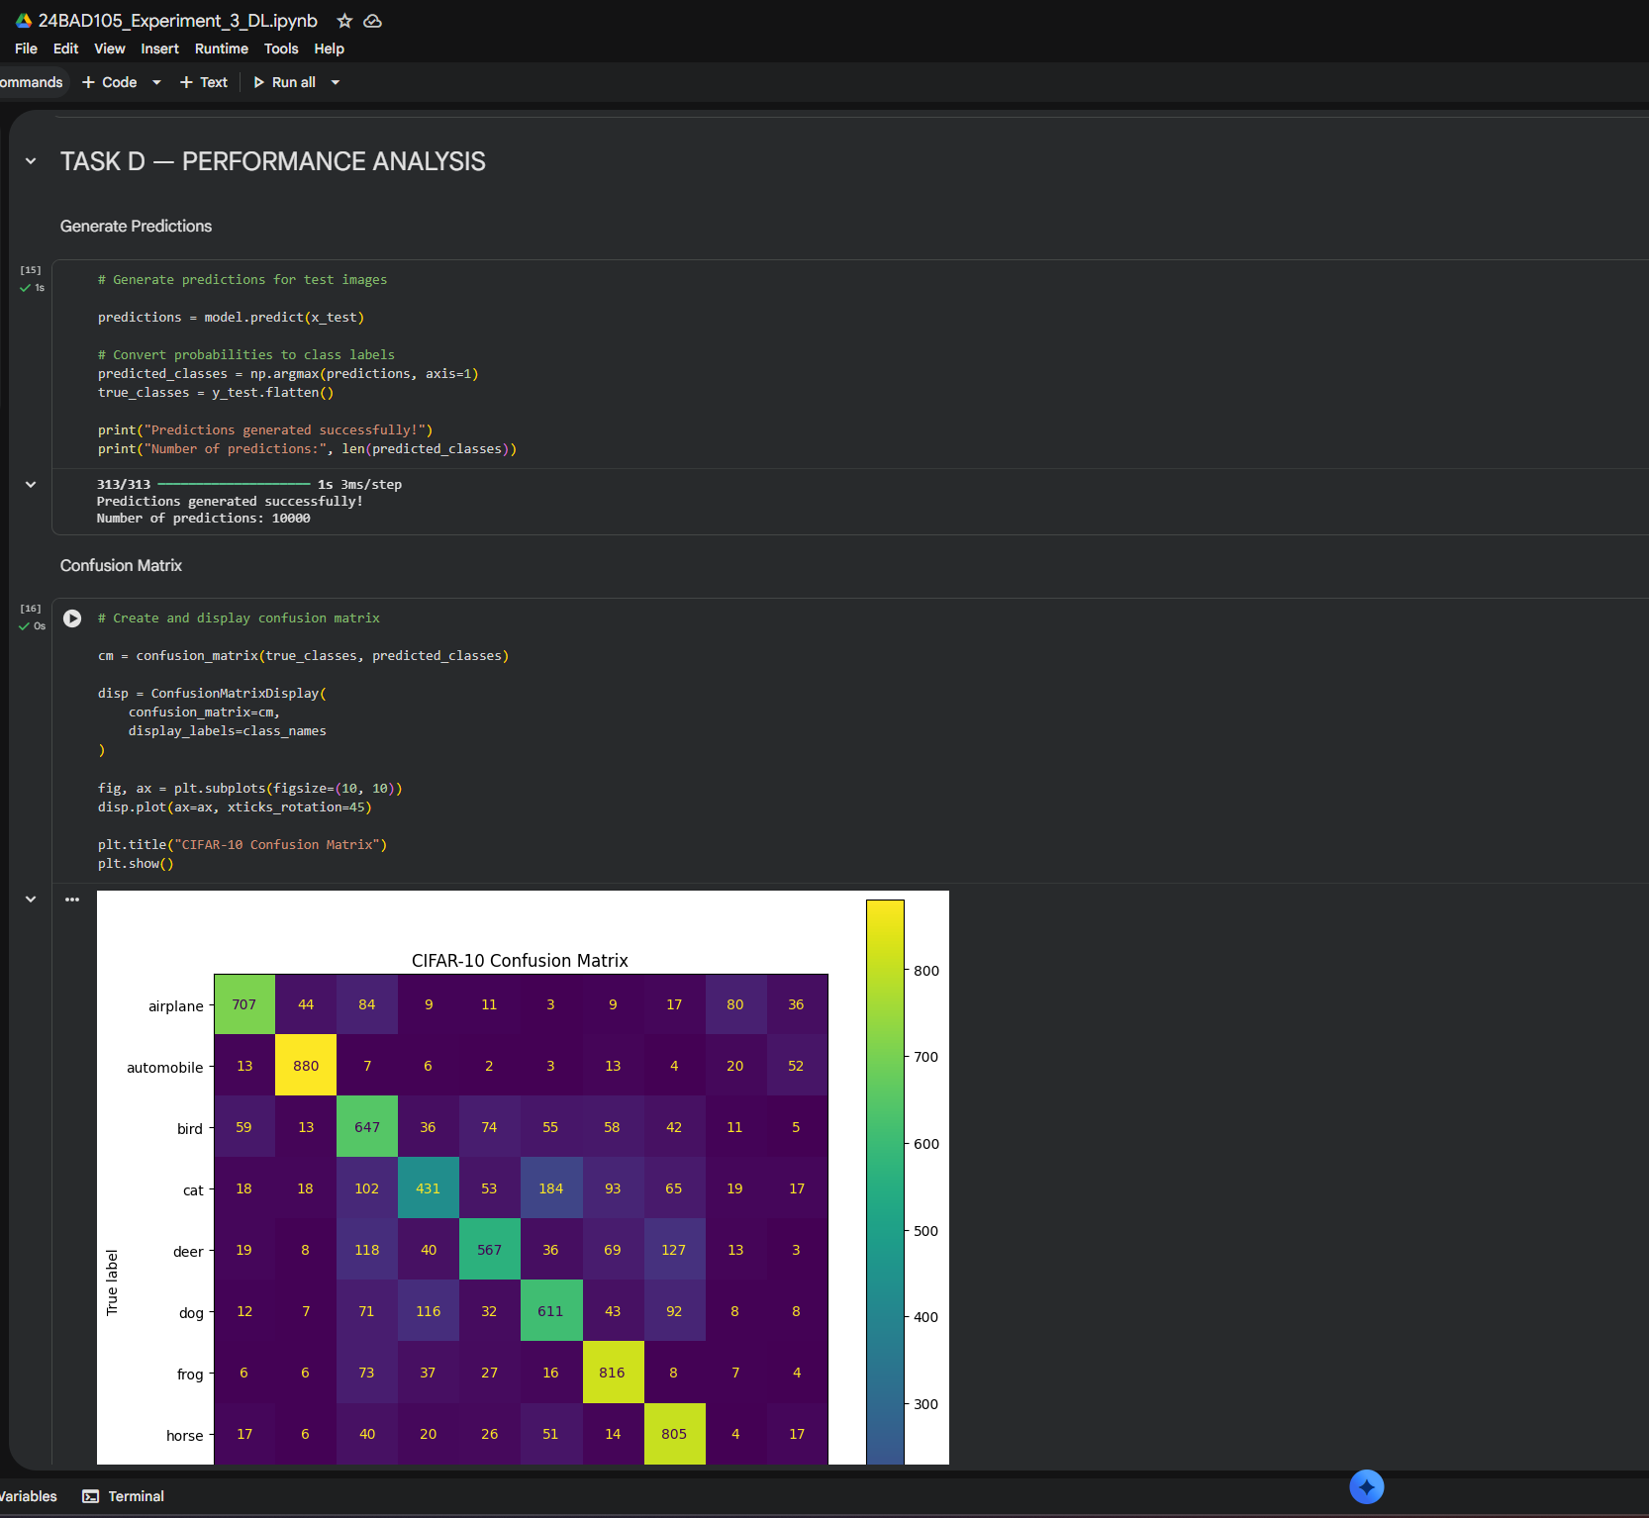

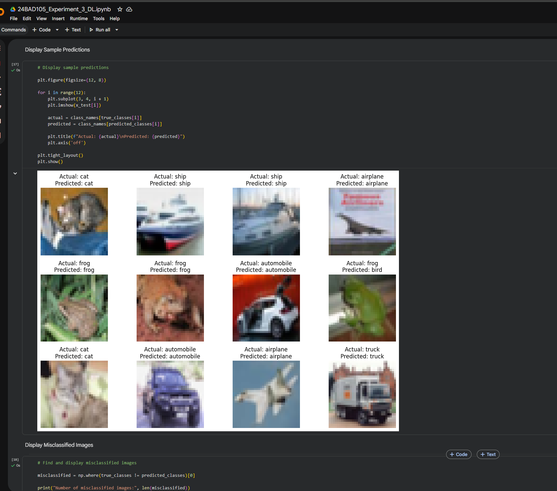

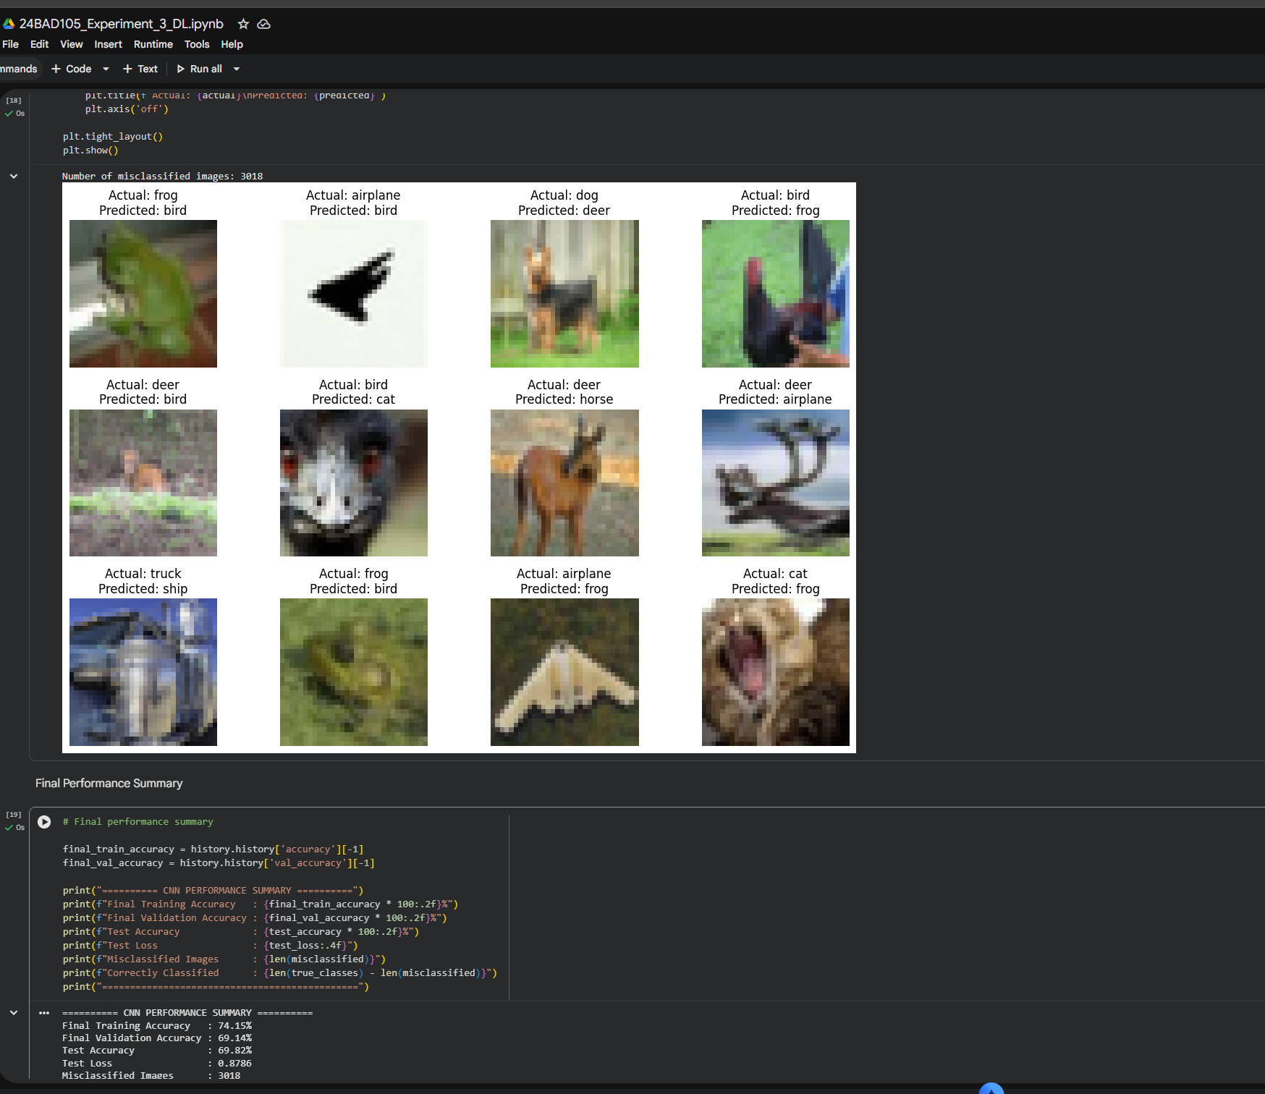

POST-LAB QUESTIONS (PROVIDE BRIEF ANSWERS TO THE FOLLOWING QUESTIONS)
- Why are convolution layers more effective than fully connected layers for image processing?

Convolution layers preserve the spatial structure of images and learn local features such as edges and textures. They also use shared weights, which greatly reduces the number of parameters compared with fully connected layers.

- How does Max Pooling improve CNN performance?

Max Pooling reduces the size of feature maps while retaining the most important features. It decreases computation, provides some translation invariance, and can help reduce overfitting.

- Which hyperparameters significantly affected your CNN model performance?

The important hyperparameters were learning rate, batch size, number of epochs, number of convolution filters, kernel size, and dropout rate. Among these, the learning rate and number of filters had a significant effect on training and accuracy.

- What challenges did you encounter while training the CNN model?

The main challenges were long training time, choosing suitable hyperparameters, avoiding overfitting, and achieving good validation accuracy. Limited computational resources can also increase training time.

- Suggest two improvements that can increase the classification accuracy of your CNN.

- Data augmentation: Use rotation, flipping, zooming, and shifting to create more varied training images.
- Transfer learning: Use a pretrained model such as VGG16, ResNet, or MobileNet and fine-tune it for the target dataset.

ASSESSMENT
Description | Max Marks | Marks Awarded
Pre Lab Exercise | 5
In Lab Exercise | 10
Post Lab Exercise | 5
Viva | 10
Total | 30
Faculty Signature

